

COMP9417

Machine Learning and Data Mining

19/T2

UNSW

COMP 9417

Machine Learning and Data Mining

T2 /2019

UNSW

* 维数灾难(Curse of Dimensionality)：通常是指在涉及到向量的计算的问题中，随着维数的增加，计算量呈指数倍增长的一种现象。

**Week 1 ----Intro to ML and DM**

* Machine Learning: Try to get program to work in a reasonable way to predict stuff
* Most widely used categories of ML algorithms

1. Supervised learning: output class (or label) is given
2. Unsupervised learning: no output class is given

(output class can be real-valued or discrete, scalar, vector, or other structure…)

There are also hybrids(混合类型), such as semi-supervised learning, and alternative strategies to acquire data, such as reinforcement learning and active learning

Supervised learning tends to dominate in applications because it is much easier to define the problem and develop an error measure (loss function) to evaluate different algorithms, parameter settings, data transformations, etc.

But, unfortunately, it’s often difficult to obtain good labelled data in sufficient quantities in the real world. So, in such case unsupervised learning is really what you want but finding good unsupervised learning algorithm for complex machine learning tasks remains a research challenge

* Machine learning models:

**根据main intuition区分**

* 1. Geometric models use intuitions from geometry such as separating (hyper-)planes, linear transformations and distance metrics
  2. Probabilistic models view learning as a process of reducing uncertainty, modelled by means of probability distributions
  3. Logical models are defined in terms of easily interpretable logical expressions

**Characterised by algorithmic properties:**

* Regression models predict a numeric output
* Classification models predict a discrete class value
* Neutral networks 神经网络learn based on a biological analogy
* Local models predict in the local region of a query instance
* Tree-based models partition the data to make predications
* Ensembled learn multiple models and combine their predications

**Intro to Regression**

* Regression(试着推测出一个连续值的结果):

1. The most widely-used and typical algorithm
2. Apply supervised learning methods for classification
3. A method of modelling target value based on independent predictors
4. Mostly used for forecasting and finding out cause and effect relationship between variables
5. Mostly differ based on the number of independent variables and the type of relationship between the independent and dependent variables

For the class of symbolic representations, machine learning is viewed as: searching a space of hypotheses and represented in a formal hypothesis language (trees, rules, graphs…)

For the class of numeric representations, machine learning is viewed as: “searching” a space of functions and represented as mathematical models (linear equations, neutral nets, …)

In both settings, the models may be probabilistic

Methods to predict a numeric output from statistics and machine learning:

1. Linear regression (statistics) determining the “line of best fit” using the least squares criterion
2. Linear models (machine learning) learning a predictive model from data under the assumption of a linear relationship between predictor and target variables

Ideas that are generalized in Artificial Neutral Networks

Regression as a term occurs in many areas of machine learning:

* Non-linear regression by adding non-linear basis functions
* Multi-layer neutral networks learning non-linear predictors via hidden nodes between input and output
* Regression trees (statistics/ machine learning) tree where each leaf predicts a numeric quantity
* Local (nearest-neighbour) regression

**Learning Linear Regression Models**

Simplest model for numerical prediction: a regression equation, outcome will be a linear sum of feature value with appropriate weights

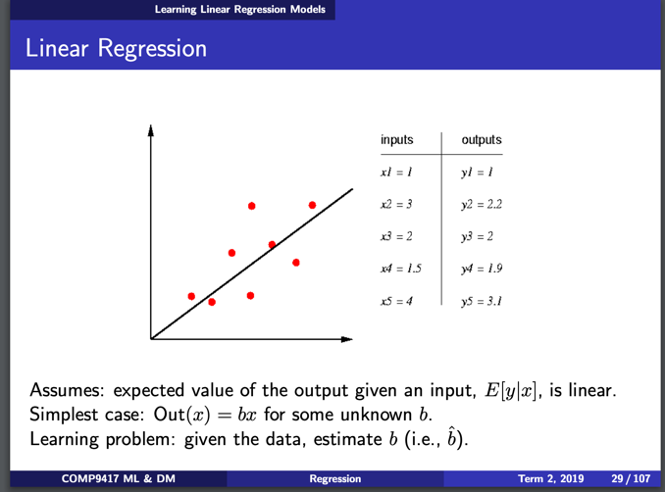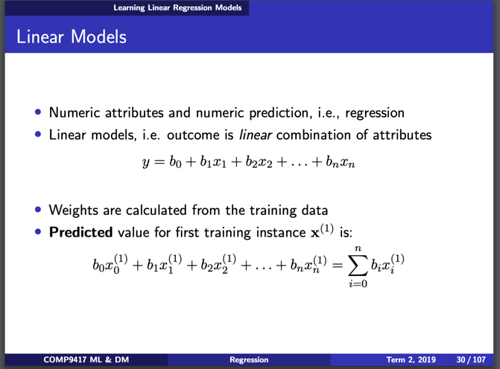

l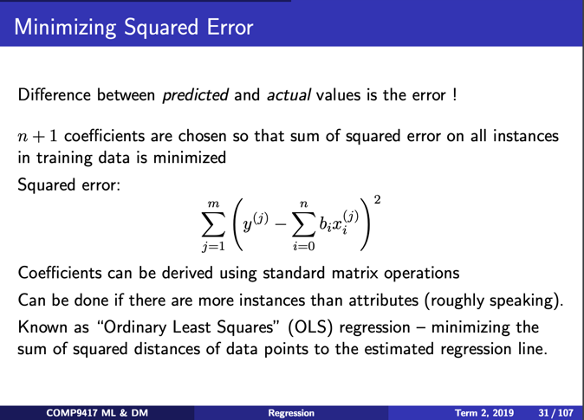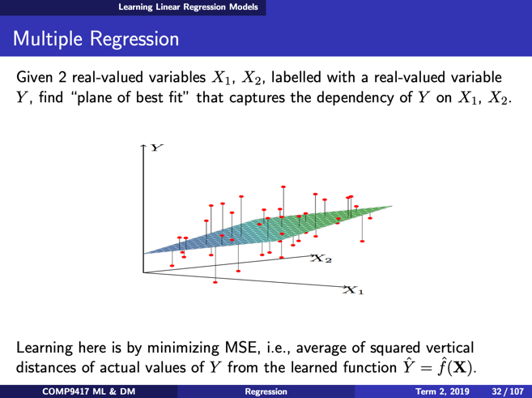

**Statistical Techniques for Data Analysis**

**Probability:**

* reasons from population to samples
* deductive reasoning (演绎推理), and is usually sound有效的 (in the logical sense of the word)

**Statistics: (统计)**

* reasons from sample to population
* inductive reasoning (归纳推理), and is usually unsound

**Statistical analyses usually involve one the 3 things:**

1. the study of populations
2. the study of variation
3. techniques for data abstraction and data reduction

**Estimation**

**Statistically unbiased**: average of a number of samples is equal to the population mean

**Mean:**

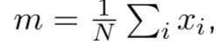 observations

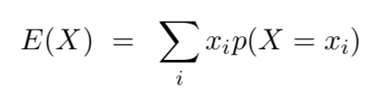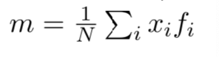frequencies

**Variance:**

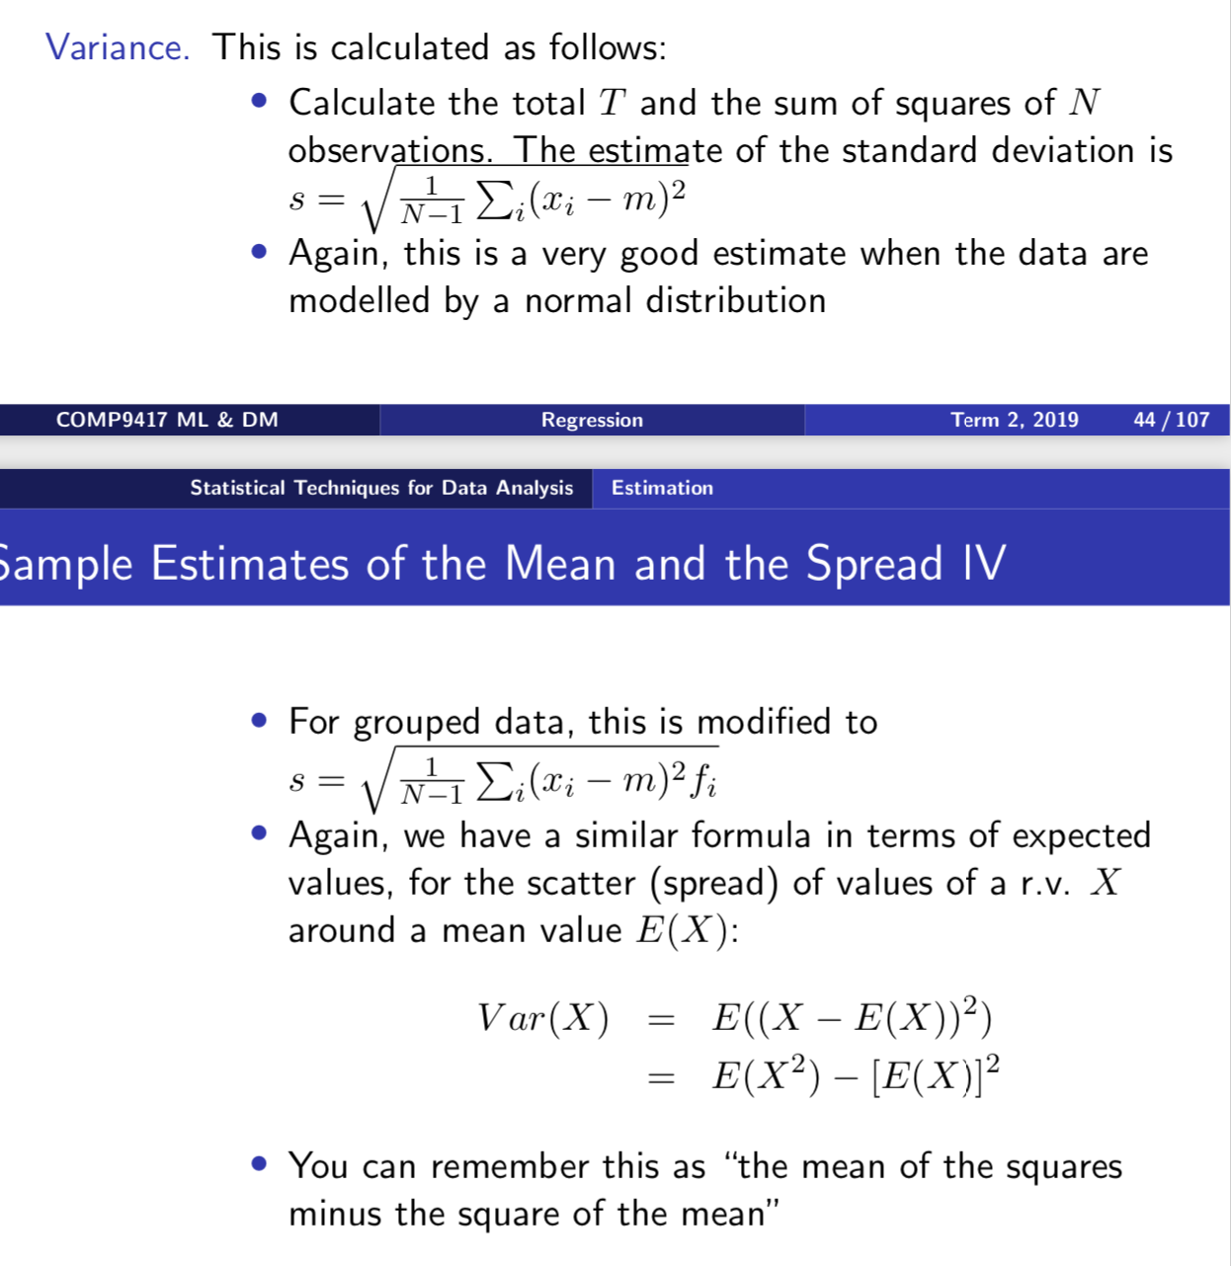

**Correlation & Covariance:**

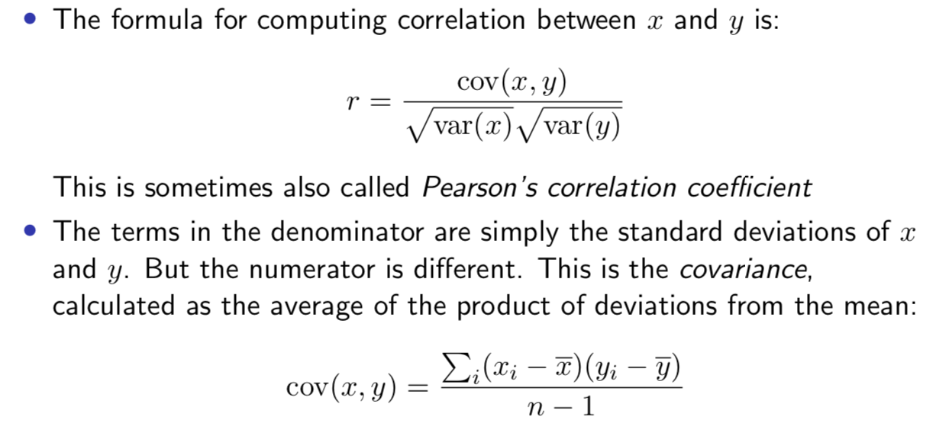

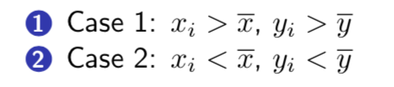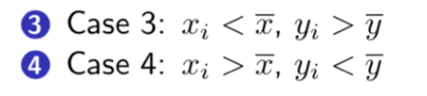

Vary together vary in different directions

Things need to remember about correlation:

* Do not use correlations to compare datasets. All you can derive is whether there is a positive or negative relationship between x and y
* Do not use correlation to imply x causes y or the other way around

**Linear Regression Model:**

1. **Univariate**
2. **Multivariate**

**可以通过algebra或者matrix的方式推导出一个linear function， 具体计算过程，参考手写笔记。**

**Week 2----Classification1 (Concept learning)**

* **Classification methods 监督学习的一种**

1. dominate machine learning
2. don’t have convenient mathematical properties like regression, more complicated to analyse
3. try to learn a classifier (分类器), which is usually a function mapping from an input data point to one of a set of discrete outputs, i.e., the classes

* **Bayesian classifier:** maintain a vocabulary of words and phrases-potential spam or ham indicators – for which statistics are collected from a training set

将多种independent pieces of evidence 组合到一起

比如 ① the prevalence of spam 1: 6② the occurrence of the word “Viagra” 4:1, 组合到一起后得到比率 4:6

优点： it can be repeated if you have further evidence

* **Rule-based classifier:**

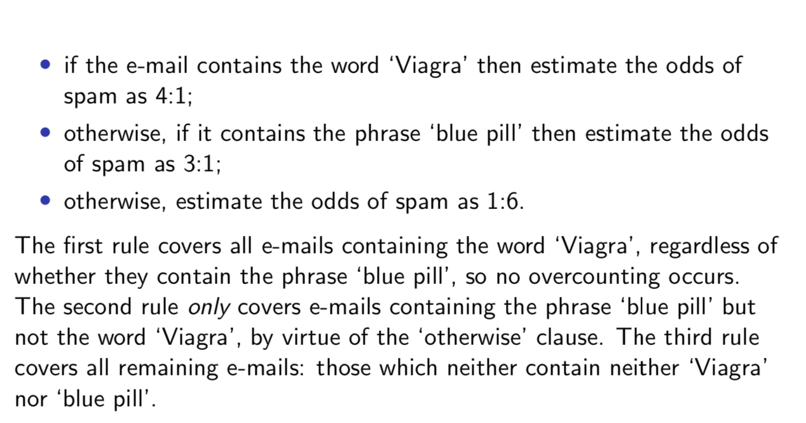

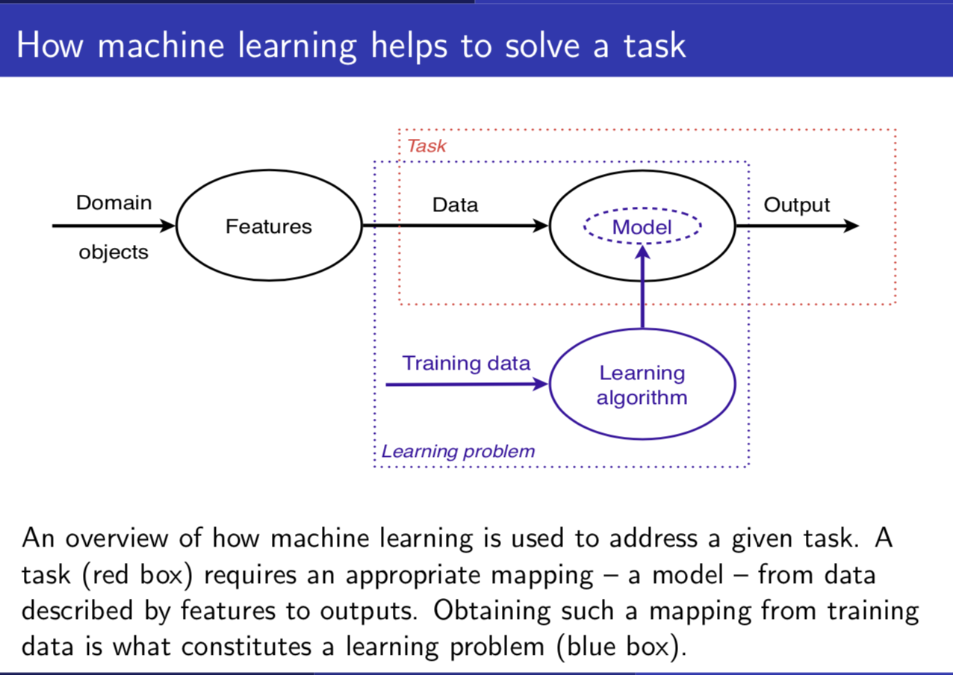

Learning problems are solved by learning algorithms that produce models

Tasks are addressed by models

* **Some terminology:**
  1. ML is concerned with using the right features to build the right models that achieve the right tasks
  2. Models lend the ML field diversity, but tasks and features give it unity
  3. Does the algorithm require *all training data to be present before the start of learning*?

**Yes** -> **batch learning 批量学习**（一次性批量输入给学习算法）

**No**-> **online learning 在线学习**（按照顺序，循序的学习，不断地去修改模型）

* 1. Model has a fixed number of parameters ----> **parametric**

Number of parameters grows with the amount of training data ----> **non-parametric**

* **The philosophical problem**
  1. **Deduction推论:** derive specific consequences from general theories
  2. **Induction归纳:** derive general theories from specific observations

Deduction is well-founded (mathematical logic)

Induction is problematic – induction is useful since it often seems to work – an inductive argument

* **Generalisation – the key objective of ML (generalising from the sample of data in our training set)**

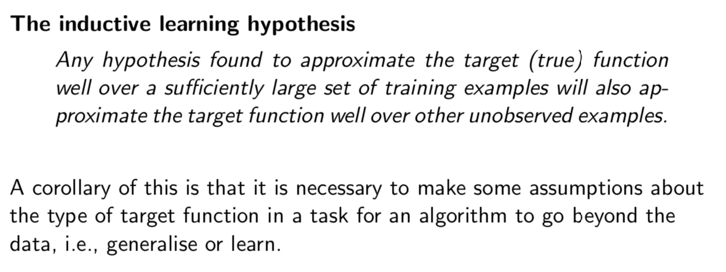

* **Cross Validation 交叉验证**

1. **什么是CV ？**

Cross validation是评估模型性能的重要方法，主要用在多个模型中（不同种类模型或同一种类不同参数组合）挑选出当前问题场景下表现最优的模型 （model selection）

1. **CV主要分为以下两类**

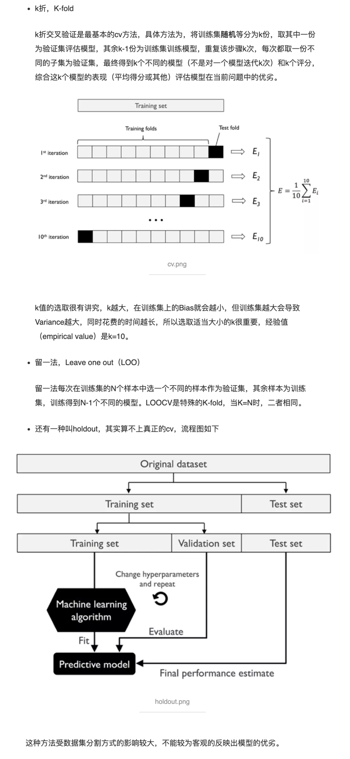

1. **为什么需要CV**

在训练集（train set）上训练得到的模型表现良好，但在测试集（test set）的预测结果不尽如人意，这就说明模型可能出现了过拟合（overfitting），bias低而variance高，在未知数据上的泛化能力差。

一个改进方案是，在训练集的基础上进一步划分出新的训练集和验证集（validate set），在新训练集训练模型，在验证集测试模型，不断调整初始模型（超参数等），使得训练得到的模型在验证集上的表现最好，最后放到测试集上得到这个最优模型的评估结果。

这个方案的问题在于模型的表现依赖于验证集的划分，可能使某些特殊样本被划入验证集，导致模型的表现出现异常（偏好或偏差）。而且训练集划了一部分给验证集后，训练模型能得到的数据就变少了，也会影响训练效果。因为通常来说，训练数据越多，越能反映出数据的真实分布，模型训练的效果就越好，越可能得到无偏估计。

交叉验证思想应运而生，交叉验证可以充分使用所有的训练数据用于评估模型。

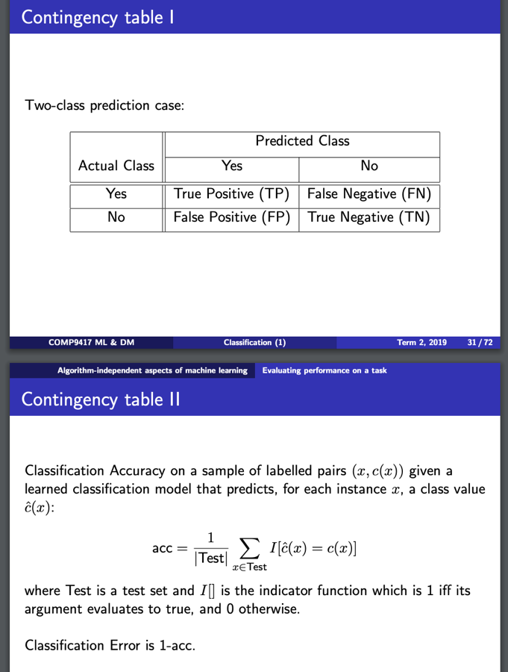

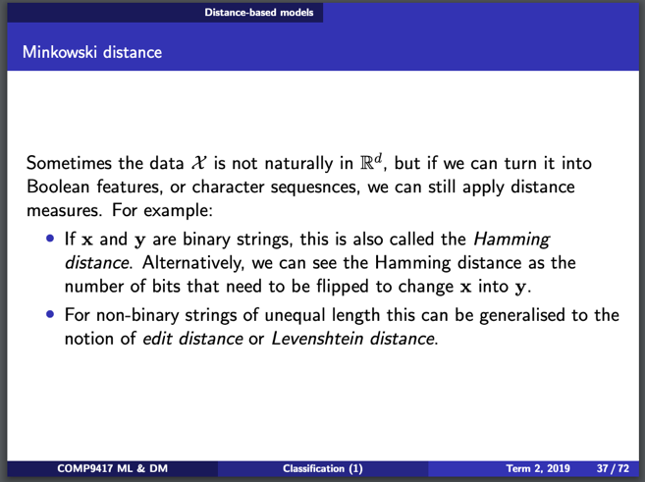



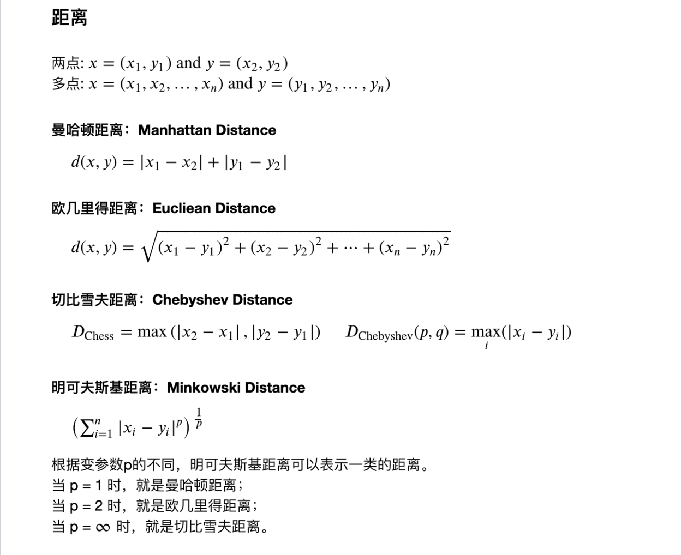



* **Nearest Neighbour**

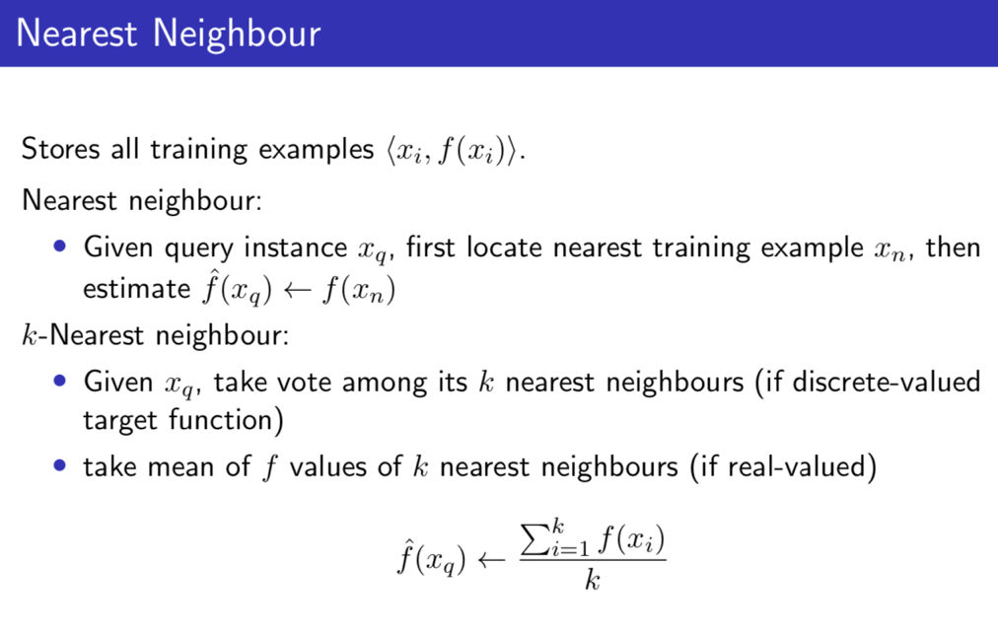



* **Advantages:**
  1. Statisticians have used k-NN since early 1950s
  2. Can be very accurate (at most twice the “Bayes error” for 1-NN)
  3. Training is very fast
  4. Can learn complex target functions
  5. Don’t lose information by generalization – keep all instances
* **Disadvantages:**
  1. Slow at query time: basic algorithm scans entire training data to derive a prediction
  2. “Curse of dimensionality” -> in high-dimensional spaces everything is far away from everything else and so pairwise distance become uninformative
  3. Assumes all attributes are equally important, so easily fooled by irrelative attributes (Remedy: attribute selection or weights)

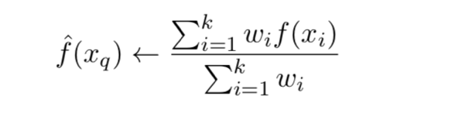

* 1. Problem of noisy instances (Remedy: remove from data set, but it’s not easy since we have no idea which are noisy)

**(k-NN适合运用在recommendation system 中)**

**Week 3----Classification2**

* **Inductive bias:**  the combination of assumptions and restrictions places on the models and algorithms used to solve a learning problem

**Examples:**

1. Linear regression:
   1. Target function has the form y = ax + b
   2. Approximate by fitting using MSE
2. Nearest neighbour:
   1. Target function is a complex non-linear function of the data
   2. Predict using nearest neighbour by Euclidean distance in feature space(特征向量的空间-----特征空间)

**What we would really like:**

* 1. A framework for machine learning algorithms
  2. With a way of representing the inductive bias
  3. Ideally, should be a declarative specification
  4. Also, should quantify uncertainty in the inductive bias

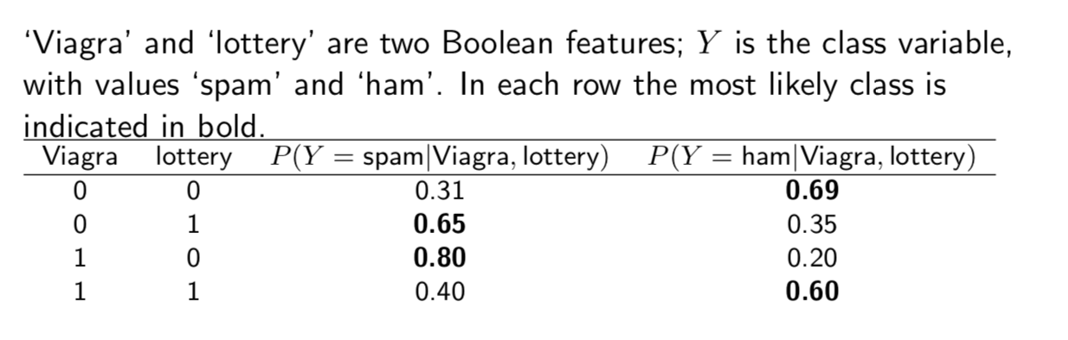

* **Decision rule** (a function which maps an observation to an appropriate action)**:**
  1. Prior probability distribution P (X|Y)
  2. Posterior distribution 后验概率分布（知果求因） P (Y|X)
  3. Joint probability distribution P (Y, X)

Y is the target variable, X are the features

* **Bayesian Machine Learning**
  1. Provides practical learning algorithm
     1. Naïve Bayes classifier learning
     2. Bayesian network learning
     3. Combines prior knowledge (prior probabilities) with observed data
     4. How to get prior probabilities
  2. Provides useful conceptual framework
     1. Provides a “gold standard” for evaluating other algorithms
     2. Some additional insight into Occam’s razor
* **Naïve Bayes algorithm**

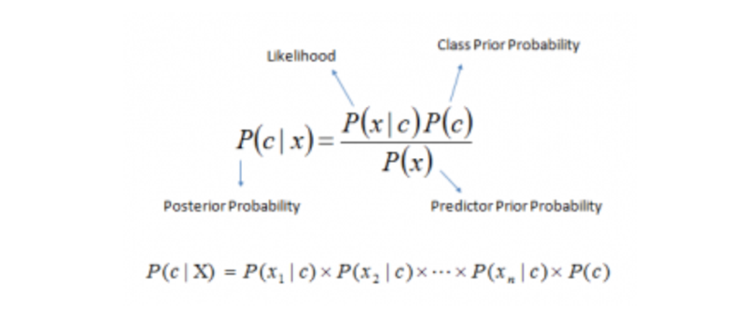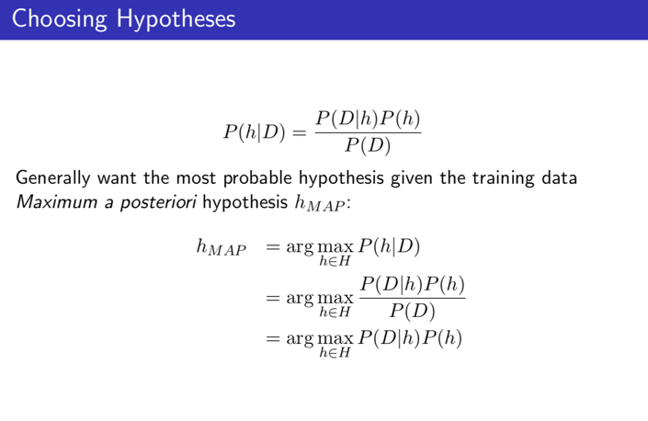

* **Basic formulas for probabilities**

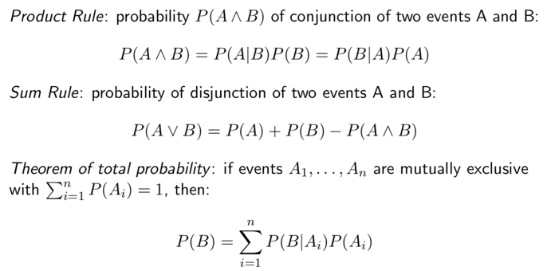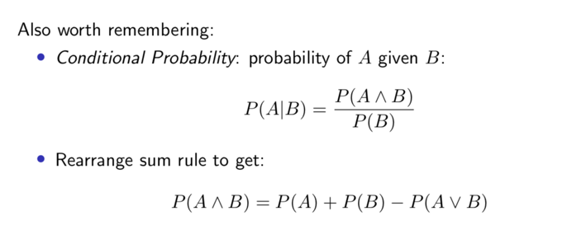

* **Discriminative & Generative probabilistic models**

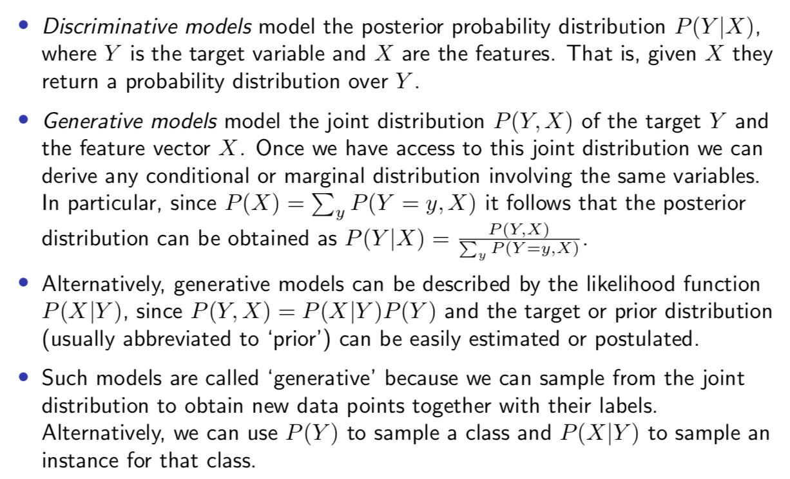

* **What are the Pros and Cons?**

**Pros:**

* It is easy and fast to predict class of test data set. It also performs well in multi class prediction
* When assumption of independence holds, a Naïve Bayes classifier performs better compare to other models like logistic regression and you need less training data
* It performs well in case of categorical input variables compared to numerical variables. For numerical variable, normal distribution is assumed (which is a strong assumption)

**Cons:**

* If categorical variable has a category (in test data set), which was not observed in training data set, then model will assign a 0 probability and will be unable to make a prediction (A.K.A “Zero Frequency”). To solve this, we can use the smoothing technique, one of the simplest examples is “Laplace estimation”.
* A bad estimator, so the probability outputs from predict probability are not to be taken too seriously
* We need to make the assumption of independent predictors. In real life, it is almost impossible that we get a set of predictors which are completely independent
* **Applications**
  1. **Multi class prediction**
  2. **Text classification/ Spam filtering / Sentiment analysis** (in social media analysis, to identify positive and negative customer sentiments)
  3. **Recommendation system**
* **How to build a basic model using Naïve Bayes?**
  1. 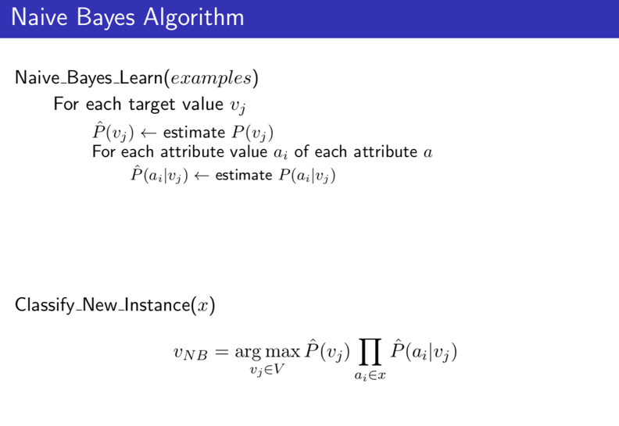**Gaussian:** It is used in classification and it assumes that features follow a normal distribution
  2. **Multinomial:** “count vectors” 🡺 count how often word occurs in the document
  3. **Bernoulli:** “Bit vector” 🡺 marked as 1 if “word occurs in the document”, and 0 if “word does not occur in the document”

**Summary：**

**classification两种算法：**

1. ***K-NN***
2. 计算查询点（query point）到每个点之间的距离(Euclidean distance …)
3. 找出k个离查询点最近的点，取平均值
4. 观察此均值在坐标系中离哪个class最近，将其归类为最近的class

可能存在的问题：

* 维度变大时，每个点之间的距离变大，此时每个点之间的距离显得意义不大
* 存在噪音点
* K值不同，算出来的结果也存在很多异议（比如5个最近的点，均值离+分类近；但是选20个最近的时，均值离-分类近）

改进方法（regularization）：

* 加上权重值

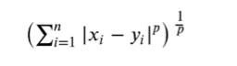 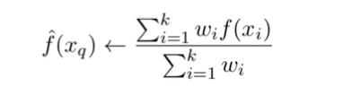

1. ***Naïve Bayes algorithm***
   1. 根据公式，计算出可能性最大的class

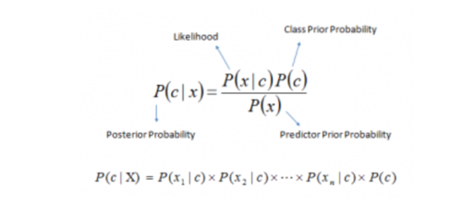 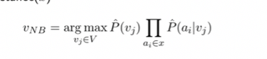

可能存在的问题：

* 当面对text classification 的问题时，有些字符可能从来没有出现过，那么根据上面的第二个公式，算出来的总probability会是0，计算失败

改进方法（smoothing）：

* + - Multinomial (count vectors), 给每个字符的出现次数都+1，再进行计算
    - Bernoulli (bit vector), +2组数据，一组数据包含所有字符，另一组数据不含这些字符，再进行计算

1. ***Logistic Regression***
2. In the case of a two-class problem, model the probability of one class P(Y = 1) vs. the alternative (1-P(Y=1)):
3. Use the formula

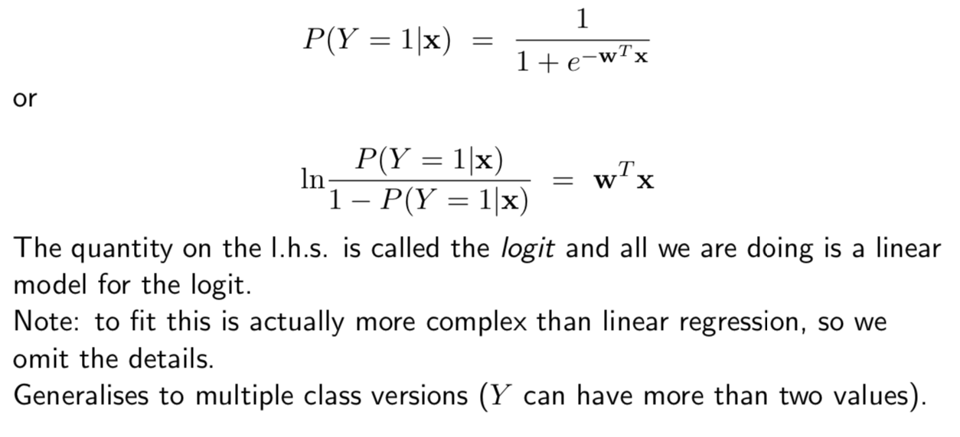

**Week 4----Decision Tree**

* **决策树（Decision Tree）**算法是一种基本的分类与回归方法，是最经常使用的数据挖掘算法之一
* **Advantages & disadvantage** 
  1. Advantage
     + 1. Easy to understand
       2. Easy to implement
       3. Easy to use
       4. Computationally cheap
  2. Disadvantage
     + 1. High variance
* **Decision tree representation**
  1. Each internal node tests an attribute
  2. Each branch corresponds to attribute value
  3. Each leaf node assigns a classification

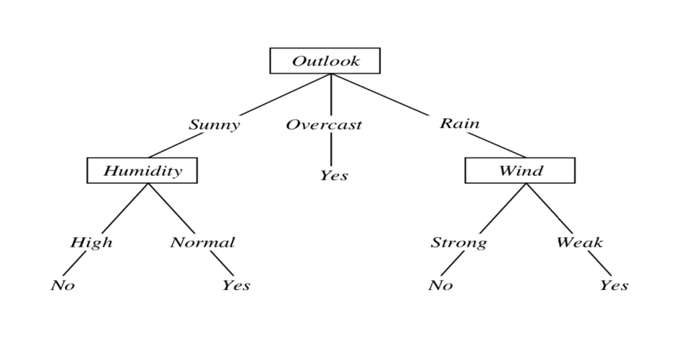

**Preference：short trees, and for those with high information gain attributes near the root**

* **When to consider decision trees**
  1. Instances described by a mix of numeric features and discrete attribute-value pairs
  2. Target function is discrete valued (otherwise use regression tree)
  3. Disjunctive hypothesis may be required
  4. Possibly noisy training data
  5. Interpretability is an advantage

**Examples:**

1. Equipment or medical diagnosis(诊断)
2. Credit risk analysis
3. Modelling calendar scheduling preferences …

* **Criterion 划分准则：**

**Information theory(信息论)**

Optimal length code assigns $-\log_{2}p$ bits to message having probability $p$

**Entropy (信息熵)**

expected # of bits needed to encode class (+ or -) of randomly drawn member of S (under the optimal, shortest-length code)

在信息论（information theory）中, 信息熵（entropy）是表示随机变量不确定性的度量，其概率分布为： P（X=xi）=pi, i=1，2，3，…, n 🡪 probability of each classes

The entropy of dataset X:

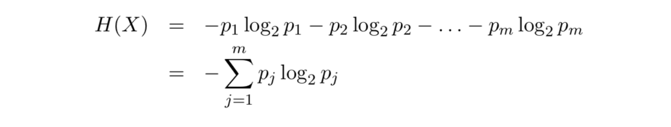 例：

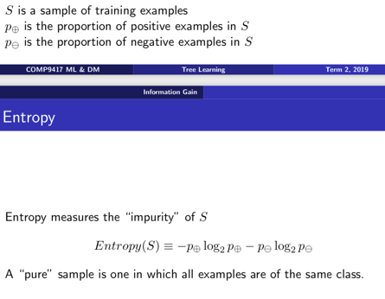“High entropy” means X is very uniform and boring

“Low entropy” means X is very varied and interesting

注：

1. 约定p = 0 时，p*log(p) = 0;
2. 当S只含一类时（纯度purity最高），此时Entropy（S）= 0 （最小值）
3. 当S中所有类占比例相同（纯度最低），此时Entropy（S） = log2（p）(最大值)

**1. ID3 算法 --------------------基于Information Gain(信息增益)准则选择特征**

$Gain\left(S, A\right)=$ expected reduction in entropy due to sorting on attribute A.

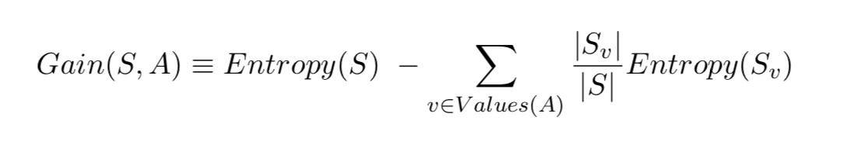

一般而言，information gain越大，则意味着用属性A来进行划分所获得的“纯度提升”越大，因此，我们可用信息增益来进行决策树的划分属性选择

**2. C4.5算法---------------------基于Gain Ratio(信息增益率)准则选择特征**

Information gain准则对可取值数目较多的属性有所偏好，可以试想，选择一个唯一对应一个样本的属性进行分类，每一类都是最纯的，对应的信息增益也是最大的，然而这样的划分无疑是不具备泛化能力的，为避免这种偏好可能带来的不利影响，C4.5算法不直接使用information gain, 而使用gain ratio 来选择最优划分属性。

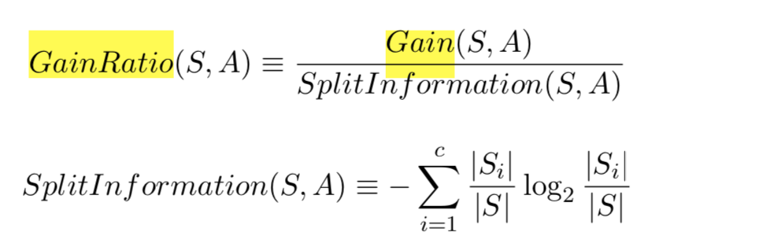

注：gain ratio对可取数目较少的属性有所偏好，因此C4.5并不是直接选择gain ratio最大的属性进行划分，而是使用了一个启发式：先从候选划分属性中找出information gain高于平均水平的属性，再从中选择gain ratio最高的。

**3. CART算法---------------------基于Gini（基尼指数)准则选择特征 （暂未涉及）**

* **Avoid overfitting by using pruning(剪枝)：**

1. **Why does overfitting occur?**
2. Noise导致的overfitting：拟合了被误标记的样例，导致误分类
3. 缺乏代表性的样本导致的overfitting：缺乏代表性样本的少量训练集做出的决策会出现过拟合
4. 多重比较造成的overfitting：复杂模型
5. **Pre-pruning (1st Method)**

**预剪枝**是指在决策树生成过程中，对每个节点在划分前先进行估计，若当前节点的划分不能带来决策树泛化性能提升，则停止划分并将单签节点标记为leaf node

1. **Post-pruning (2nd Method)**

**后剪枝**则是先从训练集生成一棵完整的决策树，然后自底向上地对非叶节点进行考察，若将该节点对应的子树替换成为叶节点能带来决策树泛化性能提升，则将该子树替换为叶节点

1. **判断决策树泛化性能是否提升：**
   1. **Reduced-error pruning**：即预留一部分数据用作“validation set验证集“以进行性能评估，移除那些显著提升验证集准确度的节点
   2. **Error-based pruning**：

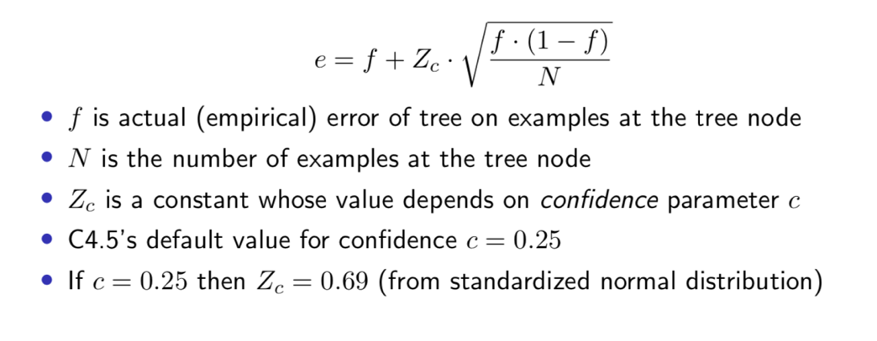

1. **对比：**
2. **预剪枝**决策树的很多分支没有“展开“，不仅降低了过拟合的风险，而且显著减少训练/测试的时间开销；但是，有些分支的当前划分虽不能提升泛化性能，但在其基础上进行的后续划分却有可能导致性能显著提高，即预剪枝基于”贪心“本质进制这些分支展开，给预剪枝决策树带来欠拟合的风险（suffer from early stopping: may stop the growth of tree prematurely）。
3. 险很小，泛化性能往往优于预剪枝；但后剪枝过程是在生成完全决策树之后进行的，并且要自底向上地对树中的所有非叶节点进行逐一考察，因此训练时间成本极大。

* **特殊值处理：**
  1. **Continuous valued attributes**

因为连续属性的可取值数目不再有限，因此不能直接根据连续属性的可取值来对节点进行划分。此时需要将连续属性离散化常用的策略是二分法（C4.5）

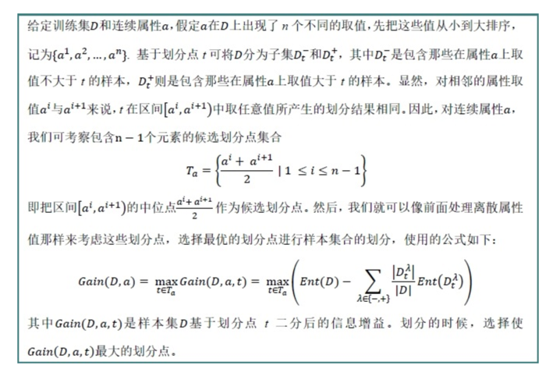

例子参考：<https://blog.csdn.net/u012328159/article/details/79396893>

* 1. **Unknown valued attribute（**即样本的某些属性值缺失）

**面临问题**：如何在属性值缺失的情况下进行划分属性选择；给定划分属性，若样本在该属性上的值缺失，如何对样本进行分类

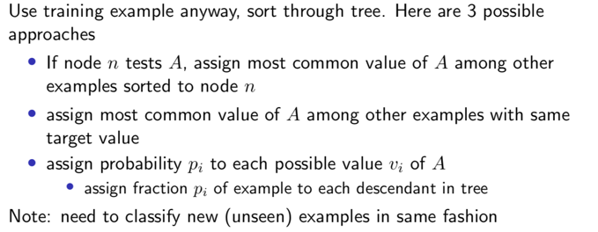

例子参考：<https://blog.csdn.net/u012328159/article/details/79413610>

* **Regression Tree**
* **Week 5----Neural Networks**
* **Perceptron:**

1. Perceptron is a single layer neural network and is a linear classifier (binary). Also, it is used in supervised learning. It helps to classify the given input data.

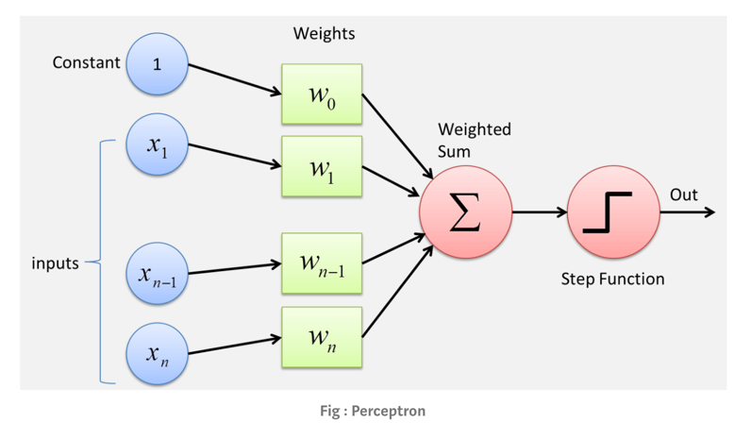

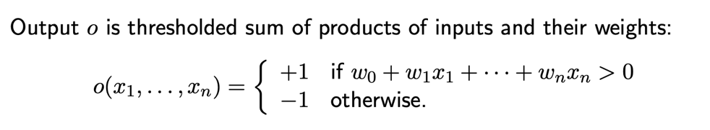

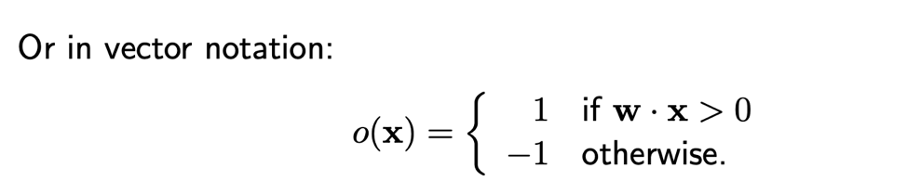

1. **The perceptron consists 4 parts:**
   1. 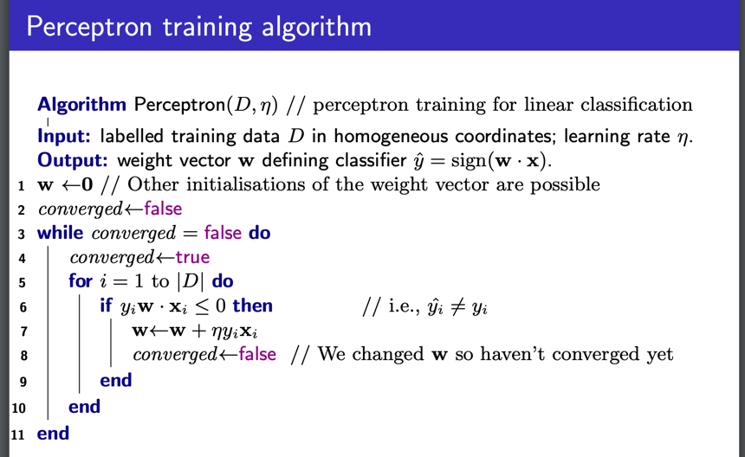Input values or One input value
   2. Weights and bias
   3. Net sum
   4. Activation Function

Perceptron中的weight是通过训练得到的，因此感知器类似于一个逻辑回归模型，可以做linear classification任务。

1. **How it works:**

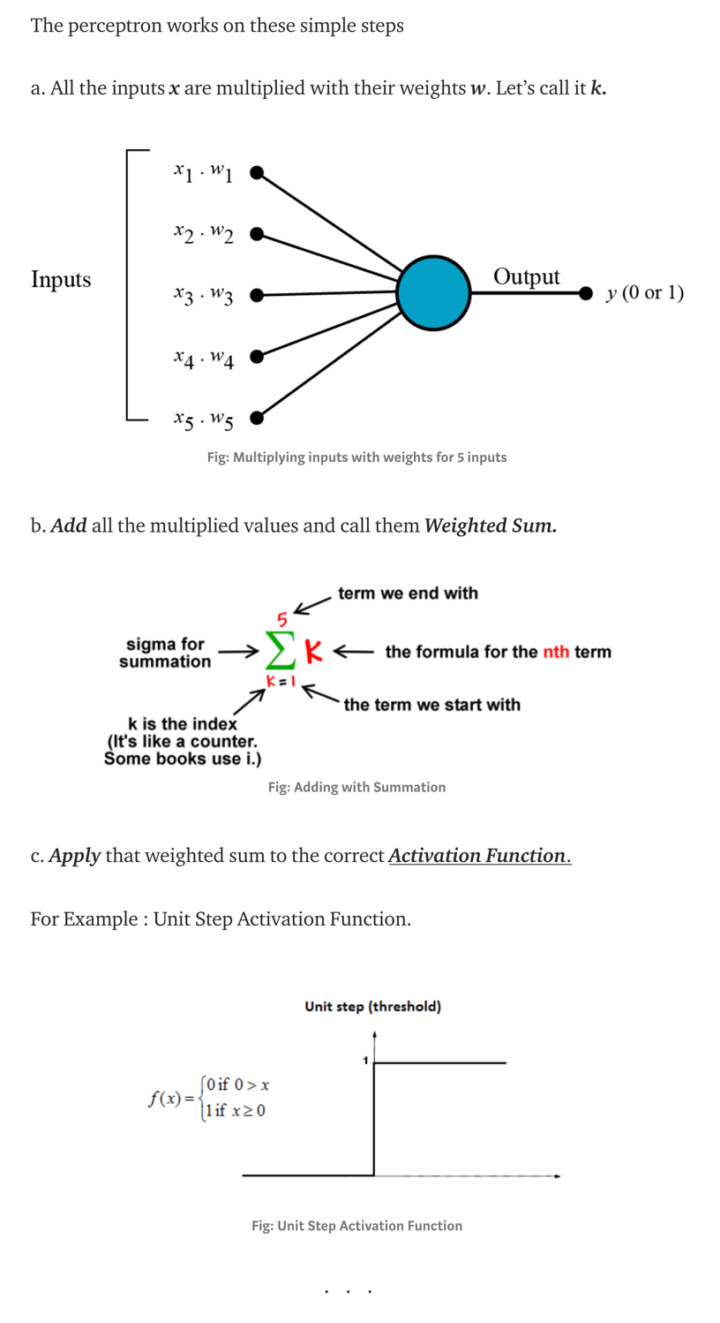

**感知器法则：**

从随机的weight开始，然后反复地对每一个训练样例应用这个感知器，在当前感知器误分类样例时修改感知器的权重，直到感知器正确分类所用的训练样例

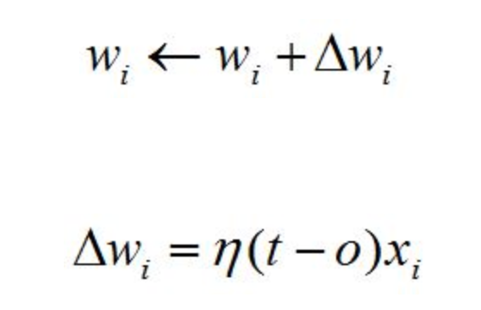

**前提：训练样例线性可分，并使用了充分小的η（learning rate）**

**如果数据不是线性可分的，那么不能保证训练过程converges**

1. **Perceptron Training Rules**
   1. 感知器法则
   2. Delta法则 使用gradient descent （详见之后的gradient descent）
2. **Where we use perceptron?**
   1. Perceptron is usually used to classify the data into two parts. Therefore, it is also known as Linear Binary Classifier

Note:

* Perceptron training will converge (under some mild assumptions) for linearly separable classification problems
* A labelled data set is linearly separable if there is a linear decision boundary that separates the classes
* **Optimization (widely used in ML)**

We would like the optimization algorithm to quickly reach an answer that is close to the right one

1. Minimize a function (error, loss) 🡪 known as gradient descent or steepest descent
2. 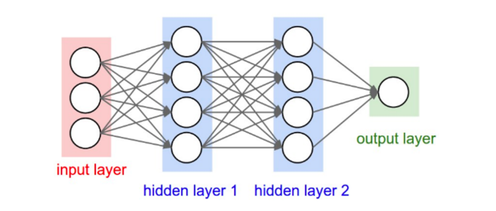Maximize a function (probability, likelihood) 🡪 known as gradient ascent or steepest ascent

* **Neural Networks**

1. **What are neural networks**
   1. A.K.A. Artificial neural networks (ANN) or connectionist systems
   2. inspired by, but not necessarily identical to, the biological neural networks
   3. “learn” to perform tasks by considering examples, generally without being programmed with any task-specific rules
   4. 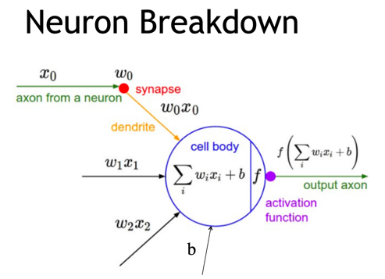Generally comprised of
      * + **Neurons** which pass input values through functions and output the result
        + **Weights** which carry values between neurons
2. **Activation functions**

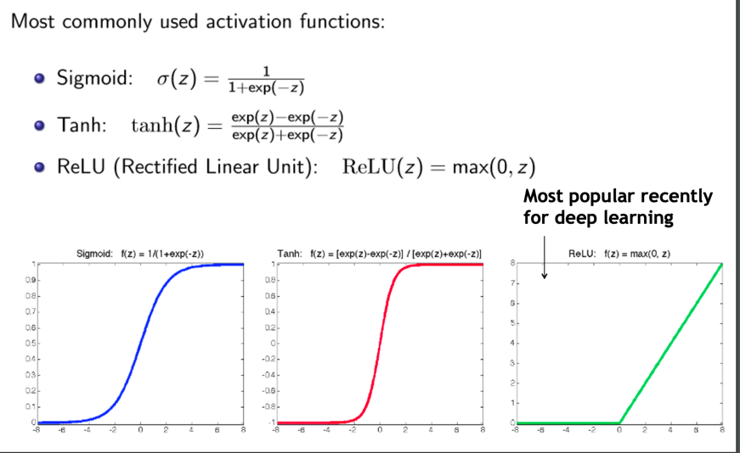



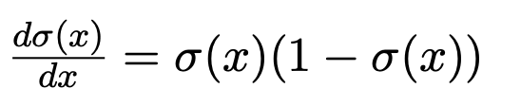 🡪 derivative of sigmoid function



COMP9417主要涉及sigmoid function

1. **When to consider Neural networks**
   1. Input is high-dimensional discrete or real-valued
   2. Output can be discrete or real-valued
   3. Output can be a vector of values
   4. Possibly noisy data
   5. Form of target function is unknown
   6. Human readability of result is unimportant
2. **Applications:**
   1. Speech recognition
   2. 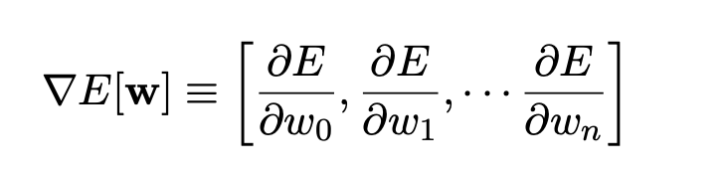Image classification …

* **Gradient descent**

- Loss Function:

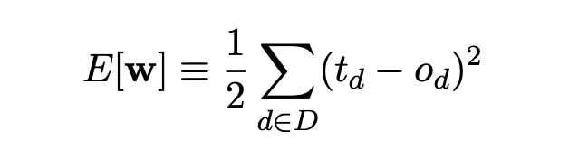 **🡪 learn [w], minimize the squared error**

Gradient vector gives direction of steepest increase in error E, and **negative** is what we want since we want to find the global/local minimum

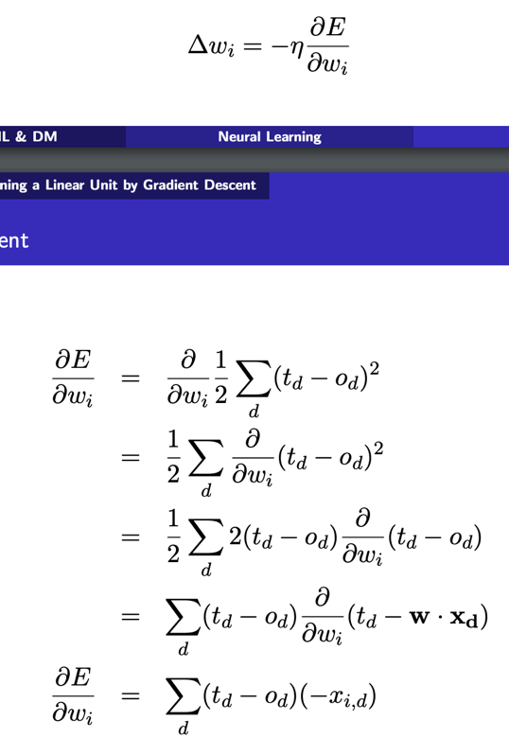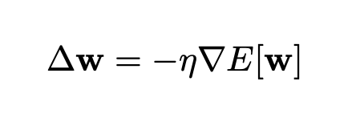

**两种方法**

* + **Batch ：**每次学习都使用整个训练集，因此每次更新都是=会朝着正确的方向进行，最后能够保证收敛于极值点，凸函数收敛于全局极值点，非凸函数可能收敛于局部极值点，缺陷是学习时机场，消耗大量内存
  + **Incremental (stochastic)：**

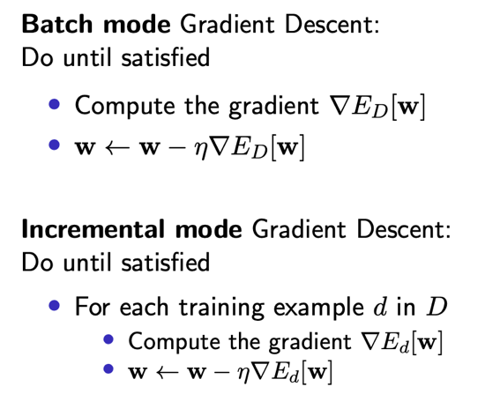一轮迭代只用一条随机选取的数据，迭代次数虽大，但是一次学习时间非常快，缺点是可能会导致loss function剧烈波动，并无法判断是否收敛

* 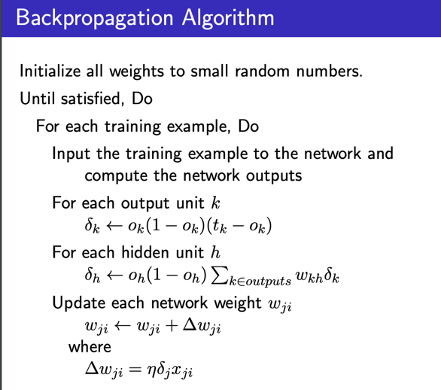**Backpropagation 反向传播**

当神经网络有百万级别的参数时，梯度下降更新权重会消耗大量时间，因此需要一种更有效的计算梯度的方法，这种方法就是反向传播。

这是一场以误差（error）为主导的反向传播运动，旨在得到最优的全局参数矩阵，进而将多层神经网络引用到分类或者回归任务中去。

前向传递输入信号直至输出产生误差，反向传播误差信息更新权重矩阵。

Will converge to a local, bot necessarily global, error minimum, but in practice, often works well (can run multiple times)

* **存在的问题 overfitting & underfitting**

1. 由于对样本数据，可能存在hidden layer的表示不唯一，即产生的分类的决策面不唯一，随着学习的进行，BP算法使权值可能收敛过于复杂的决策面，并至极致
2. 模型复杂度高
3. 权重学习迭代次数足够多（overtraining），拟合了训练数据中的噪音和训练杨立忠没有代表性的特征

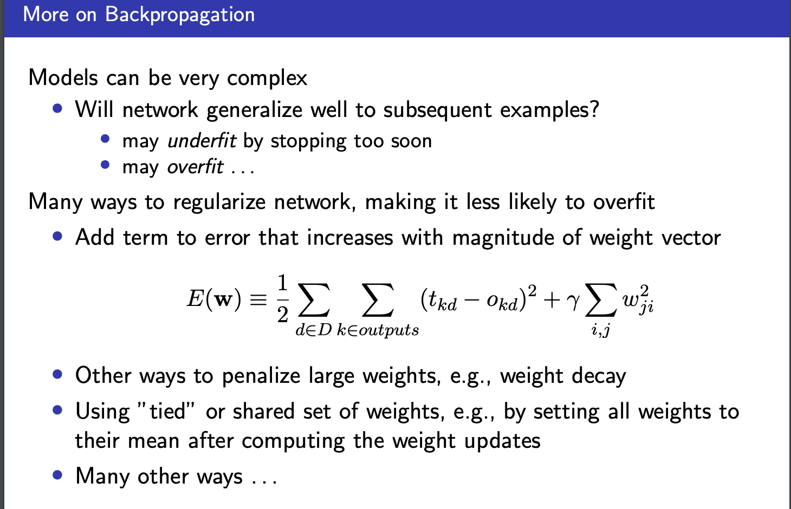

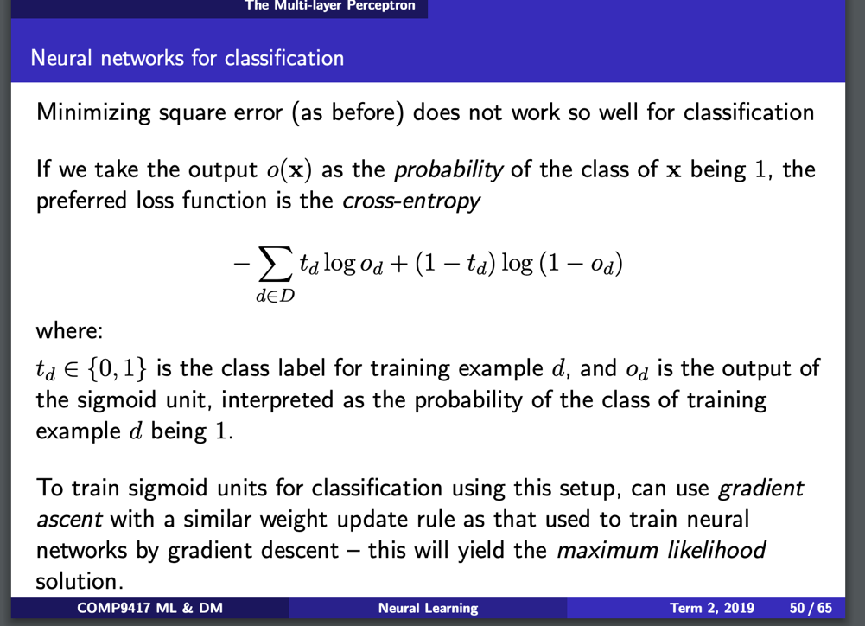

* **Week 6----Kernel Methods**
* **什么是支持向量机（SVM）？**

1、支持向量机（Support Vector Machine，常简称为SVM）是一种监督式学习的方法，可广泛地应用于统计分类以及回归分析。支持向量机属于一般化线性分类器，这族分类器的特点是他们能够同时最小化经验误差与最大化几何边缘区，因此支持向量机也被称为最大边缘区分类器。

2、支持向量机将向量映射到一个更高维的空间里，在这个空间里建立有一个最大间隔超平面。在分开数据的超平面的两边建有两个互相平行的超平面，分隔超平面使两个平行超平面的距离最大化。假定平行超平面间的距离或差距越大，分类器的总误差越小。

3、假设给定一些分属于两类的2维点，这些点可以通过直线分割， 我们要找到一条最优的分割线，如何来界定一个超平面是不是最优的呢?

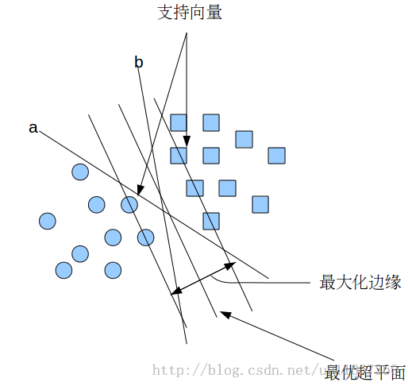如下图：

在上面的图中，a和b都可以作为分类超平面，但最优超平面只有一个，最优分类平面使间隔最大化。 那是不是某条直线比其他的更加合适呢? 我们可以凭直觉来定义一条评价直线好坏的标准:

距离样本太近的直线不是最优的，因为这样的直线对噪声敏感度高，泛化性较差。 因此我们的目标是找到一条直线（图中的最优超平面），离所有点的距离最远。 由此， SVM算法的实质是找出一个能够将某个值最大化的超平面，这个值就是超平面离所有训练样本的最小距离。这个最小距离用SVM术语来说叫做间隔(margin) 。

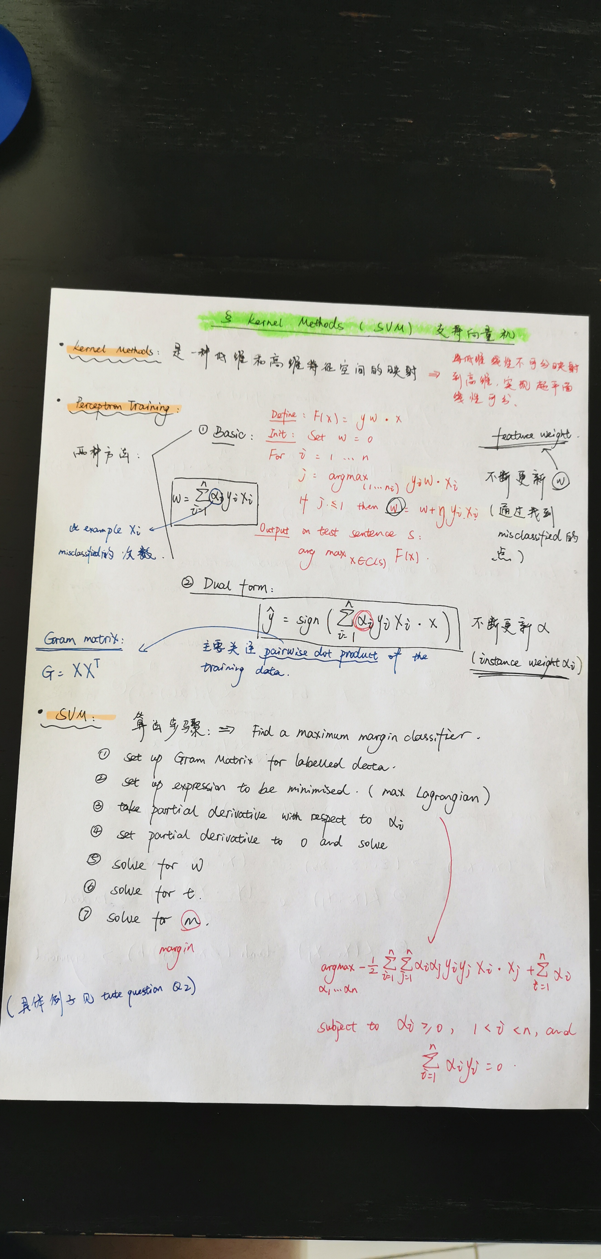

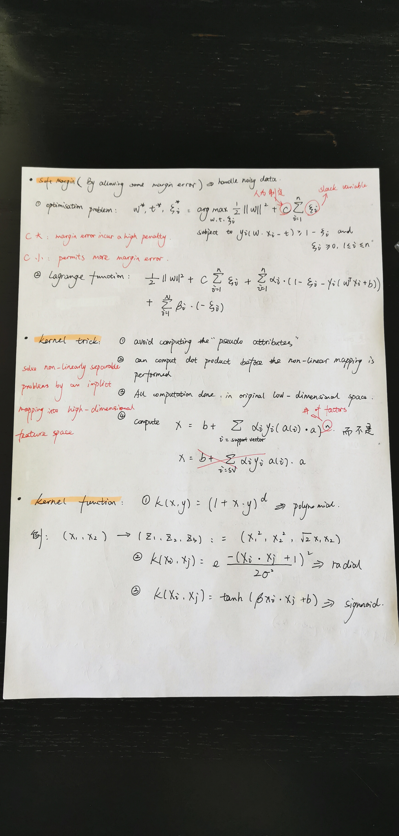

* **Week 7----Ensemble Learning**

1. **Review: bias-variance decomposition**

**In general case:**

1. Theoretical tool for analysing how much specific training set affects performance of classifier
2. Bias: is the expected error due to the mismatch between the learner’s hypothesis space and the space of target concepts
3. Variance: is the expected error due to differences in the training sets used
4. Total expected error ≈ bias2 + variance

**In ensemble classification:**

1. Bias-variance decomposition used to analyse how much restriction to a single training set affects performance
2. Bias = expected error of the ensemble classifier on new data (包含noise inherent in the data)
3. Variance = component of the expected error due to particular training set being used to build classifier
4. Total expected error ≈ bias + variance

Possible solution: “Big Data”

1. 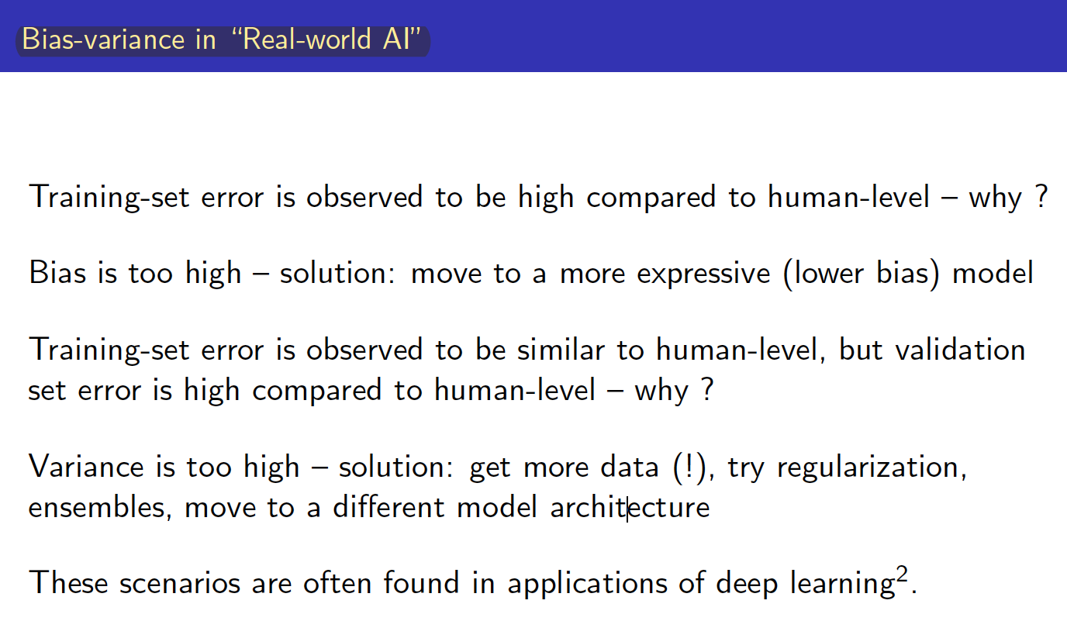**Bias variance trade-off**

**WHY?**

- To avoid overfitting and underfitting conditions

- To have consistencies in predictions

**Note:** Optimal bias and variance trade-off lead to better consistency and more reliable model

**Bias & variance in ML**

**ERRORS DUE TO BIAS**

* Expectation of error in predictions of a model
* Error due to assumptions in the model

Ex: Linear regression

Assumption: The target has linear relationship with features

High bias signifies underfitting

___________________________________________________________________________________

**ERRORS DUE TO BIAS**

* Measure of variability in the results given by model when the dataset is changed

High variance signifies overfitting

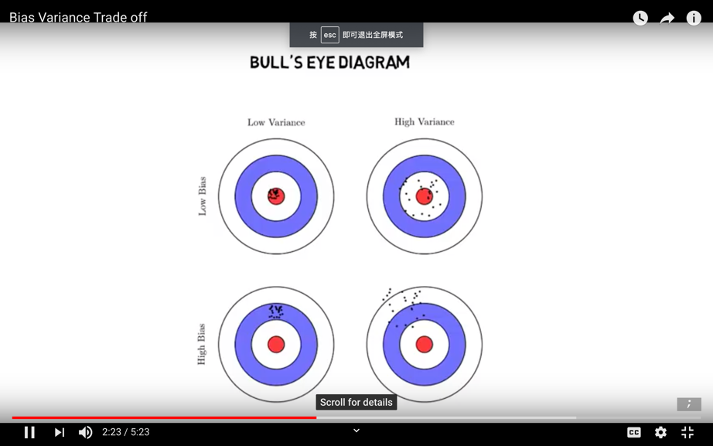

**How?**

1. Dimensionality reduction
2. Regularization in linear models / ANN
3. Using mixture model and ensemble learning
4. **Stability**

For a given data distribution D, train algorithm L on training sets S1, S2 sampled from D, expect that the model from L should be the same on both S1 and S2, then we say L is a stable learning algorithm.

Typical stable algorithm: KNN (typically have high bias)

Typical unstable algorithm: decision-tree learning (typically have high variance)

1. **Ensemble methods**

**Have the following things in common:**

* 1. They construct multiple, diverse predictive models from adapted versions of the training data
  2. They combine the predictions of these models in some way, often by simple averaging or voting (possibly weighted)
  3. ADVATTANGES: often improves predictive performance
  4. DISADVANTAGES: produces output that is very hard to interpret

***Bootstrap（一种抽样方法）***

* 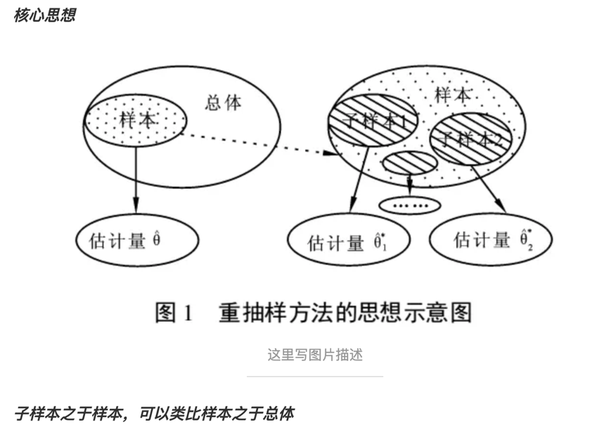现在统计学较为流行的一种统计方法，在小样本时效果很好。
* 是一个在自身样本重复采样的方法来估计真实分布的问题
* 当不知道样本分布时，bootstrap方法最有用
* 整合多个弱分类器，成为强大的分类器。这时候，ensemble classifier出现了 。

***1st Bagging (Bootstrap Aggregation)***

***---抽取训练样本的时候采用的是bootstrap <用来减少variance>***

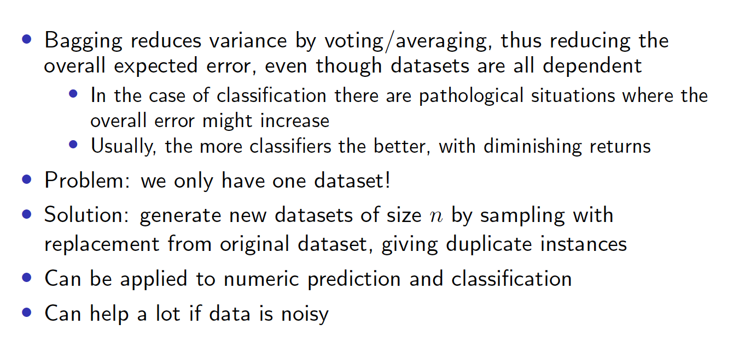

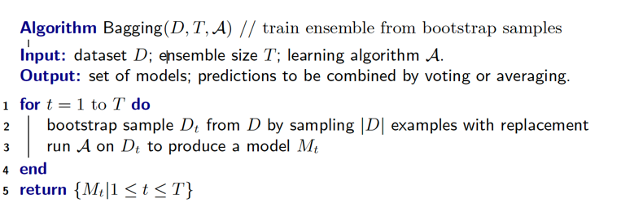 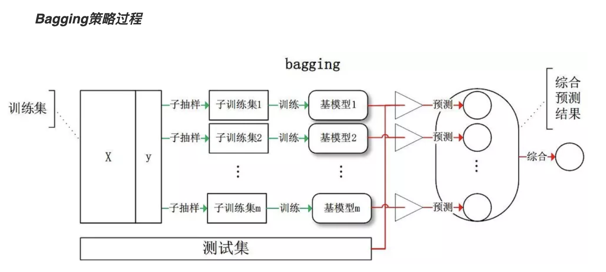

**Bagging代表算法 – Random Forest (随机森林) 并行集成**

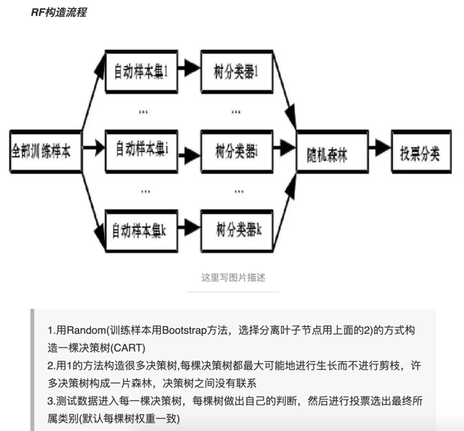

其中random表示：

* 训练样本选择方面的random （Bootstrap方法随机选择子样本）
* 特征选择方面的random （属性集中随机选择k个属性，每个树节点分裂时，从这随机的k个属性中，选择最优的）

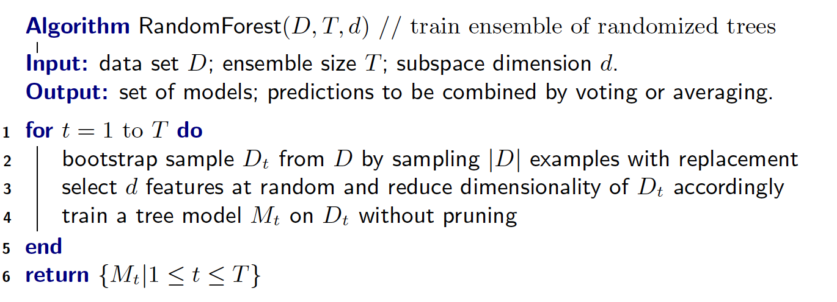

优点：

* Forces more diversity among trees in ensemble
* Less time to train since only consider a subset of features

***2nd Boosting <用来减少bias>***

Boosting works with weak learners: only condition is that error rate <= 0.5

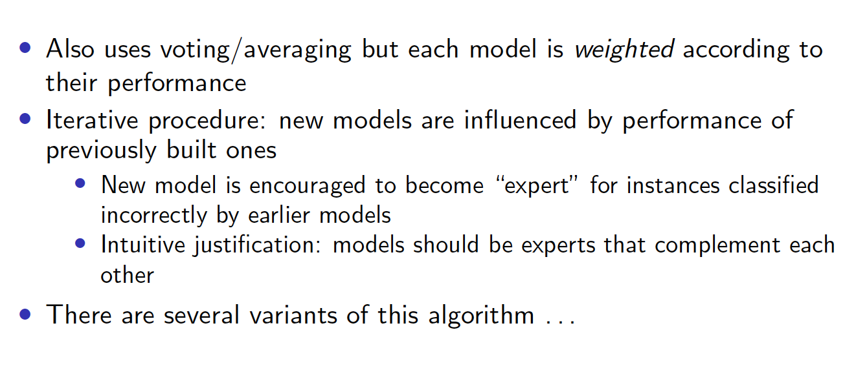

Note：

* + - Learner produces a binary [+1, -1] classifier h with error rate < 0.5
    - Strong learner if error rate < 0.5 and error rate “close” to zero
    - Weak learner if error rate > 0.5 and error rate “close” to 0.5

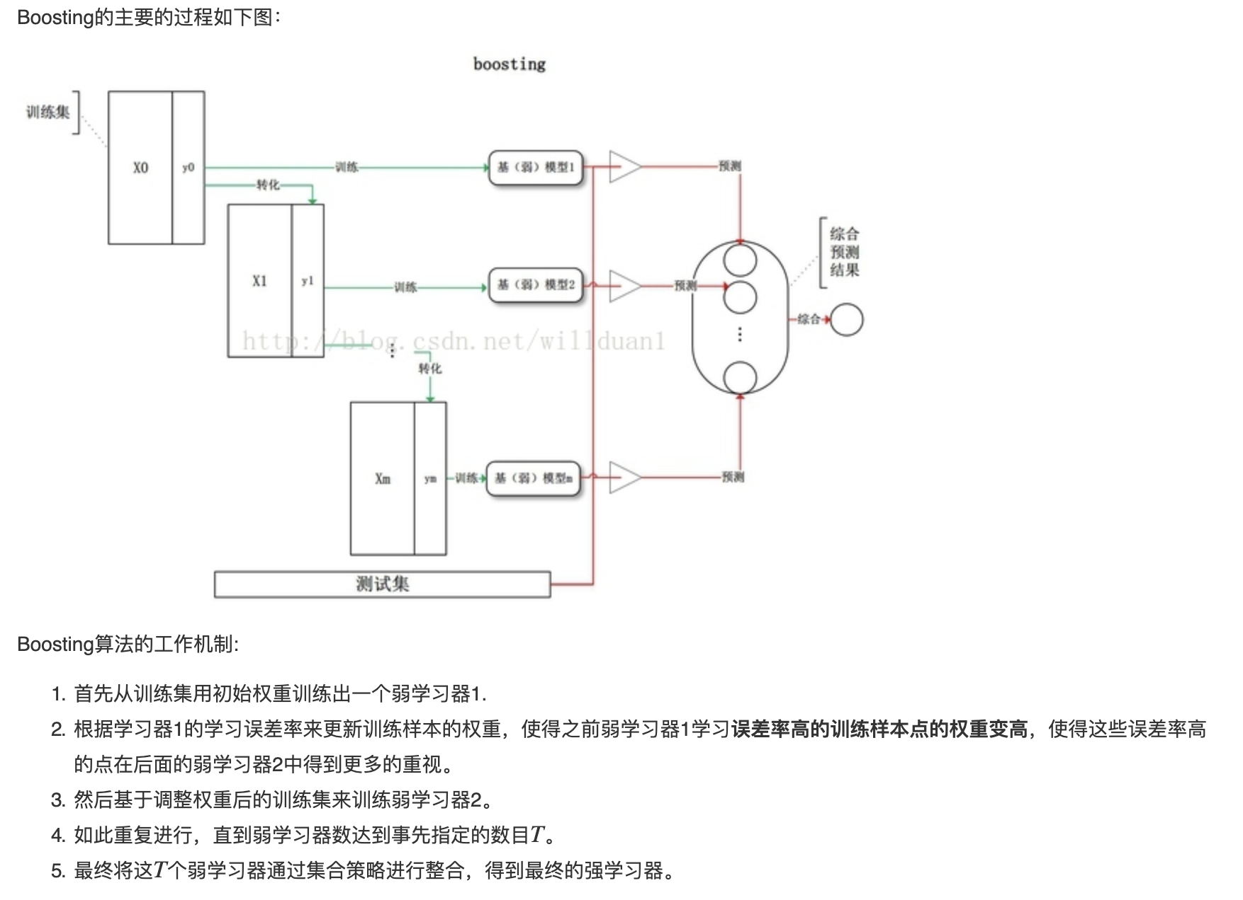

**Boosting代表算法一 – Adaboost（Adaptive Boosting）串行集成**

**Boosting代表算法二 – Gradient Boosting**

**核心思想：**

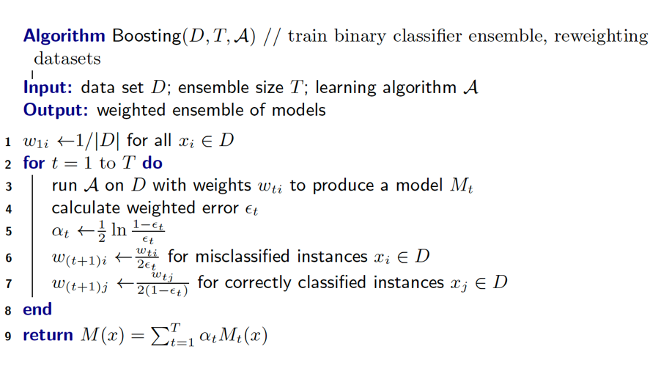一种迭代算法，针对同一个训练集训练不同的分类器（弱分类器），然后进行分类，对于分类正确的样本权重低，分类错误的样本权值高，最后分类器是很多弱分类器的线性叠加（加权组合）。实际上就是一个简单的弱分类算法提升（boost）的过程。

***3rd Stacking <用来提升预测结果>***

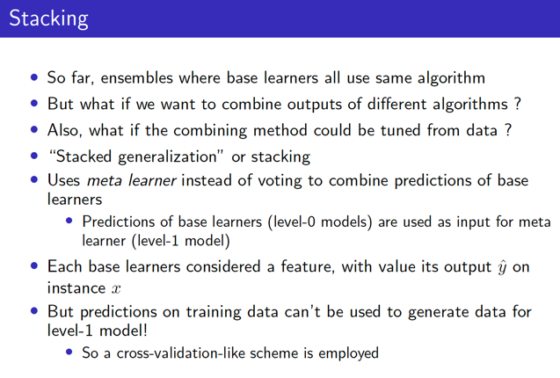

原理： Stacking是在弱学习器的基础上再套一个算法，用机器学习算法自动去结合之前的弱学习器。

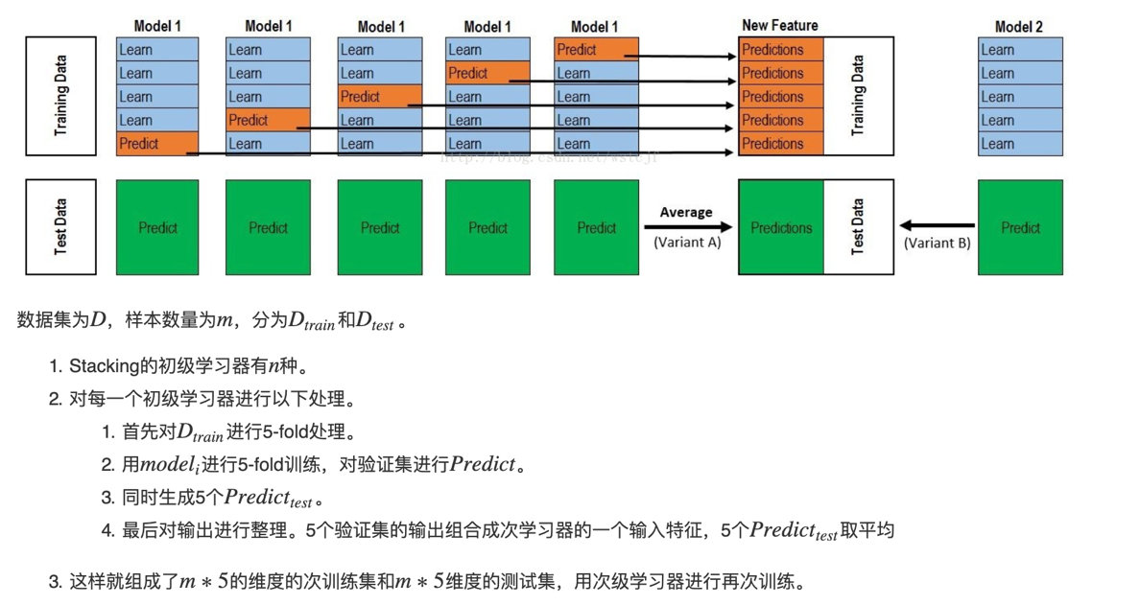

* **Week 8----Unsupervised Learning**